Lab - Guideline

Topics
- Subnneting IPv4
- Router

- Subnneting IPv4

- Static vs. dynamic addressing

- IPv4 address structure

network ID | host ID

Class | 1st Octet Decimal Range | 1st Octet High Order Bits | Network/Host ID (N=Network, H=Host) | Default Subnet Mask
A | 1 – 126* | 0 | N.H.H.H | 255.0.0.0
B | 128 – 191 | 10 | N.N.H.H | 255.255.0.0
C | 192 – 223 | 110 | N.N.N.H | 255.255.255.0
D | 224 – 239 | 1110 | Reserved for Multicasting
E | 240 – 254 | 1111 | Experimental; used for research
Note: Class A addresses 127.0.0.0 to 127.255.255.255 cannot be used and is reserved for loopback and diagnostic functions.

- Network Mask

Class A: 255.0.0.0 /8
Class B: 255.255.0.0 /16
Class C: 255.255.255.0 /24

- Private IP addresses

Class A: 10.0.0.0 - 10.255.255.255 /8
Class B: 172.16.0.0 - 172.31.255.255 /16
Class C: 192.168.0.0 - 192.168.255.255 /24
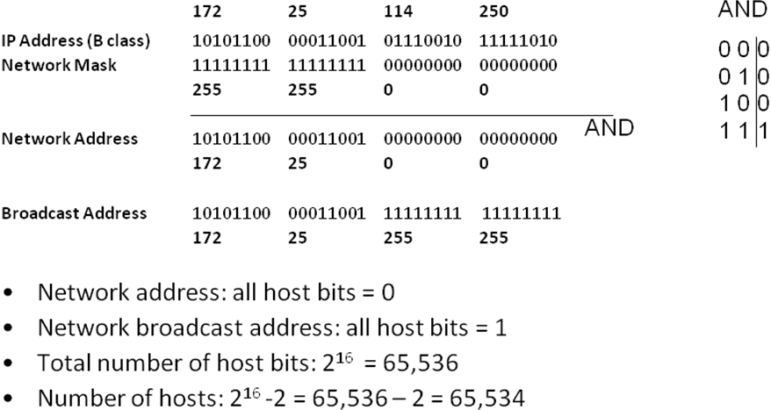

- Creating subnets:
- borrow bits from the host ID
- create a new Network Mask to show the new structure of the IPv4

network ID | subnetwork ID | host ID

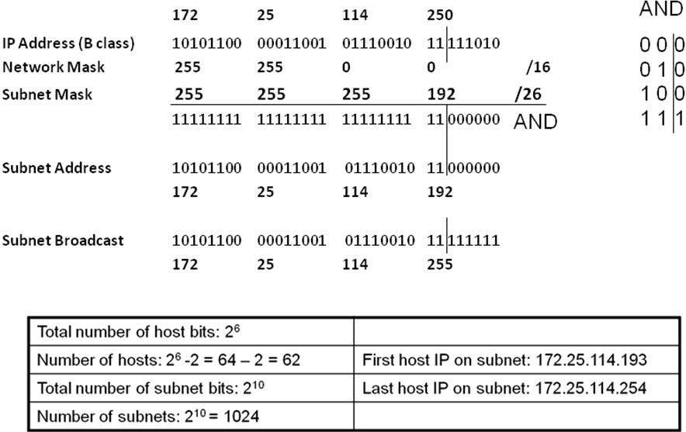

Exercises:

- Determine the network and broadcast addresses and number of host bits and hosts for the given IPv4 addresses and prefixes:
IPv4  Address/Prefix | Network Address | Broadcast Address | Total Number  of Host Bits | Total Number  of Hosts
172.16.104.99/27
198.133.219.250/24
10.1.113.75/19

- Having the following information, compute subnets with the following constrains:
  - A number of 62 subnets
Host IP Address: 172.16.33.45
Original Subnet Mask 255.255.0.0

62 subnets = 6 bits (2⁶ = 64)
New subnet mask:
255.255.111111|00.00000000 => 255.255.252.0
Subnet1:
172.16.000000|00.00000000 => 172.16.0.0 (subnetwork address)
172.16.000000|11.11111111 => 172.16.3.255 (broadcast address)

Subnet2:
172.16.000001|00.00000000 => 172.16.4.0 (subnetwork address)
172.16.000001|11.11111111 => 172.16.7.255 (broadcast address)

…….

- Having the following information, compute subnets with the following constrains:
  - A maximum number of 29 hosts/subnet
Host IP Address: 192.168.200.139
Original Subnet Mask 255.255.255.0

- Having the following information, compute subnets with the following constrains:
  - A number of 250 subnets
Host IP Address: 10.18.154.9
Original Subnet Mask 255.0.0.0

Test the connectivity on IPv4:
- ipconfig /all (ifconfig on Linux)
- ipconfig /release and ipconfig /renew (dhclient on Linux)
- ping, tracert (traceroute on Linux)
- nslookup
- route print (display routing table)
B. Packet Tracer
Laboratory test configuration:

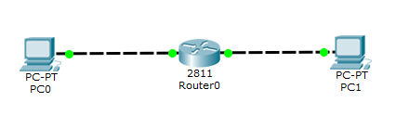
Step0: Enter configuration mode
Router>enable
Router#configure terminal
Router(config)#

Step1: Assign static IPv4 address to the router interfaces

Router(config)#interface fastethernet 0/0
Router(config-if)#ip address 192.168.0.1 255.255.255.0
Router(config-if)#no shutdown
Description: Add an IP address on Fa0/0 interface

Step3: Display info

Router#show ip interface brief
Description: Display IP information about router’s interfaces

Router#show ip route
Description: Display IP routing table

Step4: Configure IP addresses on the PCs

Test the connectivity.
  - check IP addresses oh hosts computers
  - ping <target IP>

